Casos de uso y diagrama de secuencias

Sequence Diagram Specification

Author: Author

Revision: 0.2

|  |  |
| --- | --- |
| No Magic |  |
| One Allen Center, 700 Central Expressway South, Suite 110 Allen, Texas 75013 USA | Date: mayo 23, 2019 |

**Approval**

|  |
| --- |
| The original of this document is approved and signed by:  Name: Marta  Surname: Romero Sanchez  Title: Diagramas de secuencia  Date: 23/05/19  Signature: Rocket Motors |

**Revision History**

|  |  |  |  |
| --- | --- | --- | --- |
| **Revision** | **Date** | **Description** | **Author** |
| 0.1 | <date 1> | <draft> | <Author name> |
| 0.2 | <date 2> | <release> | <Author name> |
|  |  |  |  |

**Table of Contents**

Microsoft Word users please click here and press F9 to create Table of Contents.

OpenOffice.org users please remove this text and select Insert Table of Content from menu.

**Table of Figures**

Microsoft Word users please click here and press F9 to create Table of Contents.

OpenOffice.org users please remove this text and select Insert Table of Content from menu.

# Introduction

## Purpose

<This document provides an overview of the sequence diagram messages.>

## Scope

<Provide a short description of the system being specified and its purpose, including relevant benefits, objectives, and goals.>

## Overview

<Describe what the document contains and explain how the document is organized>

# Model

## Lifeline

### : Cliente

# Cliente

## Message Summary

|  |  |  |  |  |
| --- | --- | --- | --- | --- |
| **No.** | **Message Name** | **Sender** | **Receiver** | **Constraints** |
| 1 | 1090905605.jpg Nuevo Usuario | -841932111.jpg  : Cliente | 1431574347.jpg Crear Cuenta |  |
| 2 | 1090905605.jpg Añadir contraseña | -841932111.jpg  : Cliente | 1431574347.jpg Crear Cuenta |  |
| 3 | 1090905605.jpg Añadir coche (Opcional) | -841932111.jpg  : Cliente | 1431574347.jpg Crear Cuenta |  |
| 4 | 1090905605.jpg Cambiar contraseña | 1431574347.jpg Crear Cuenta | 1431574347.jpg Crear Cuenta |  |
| 5 | 1090905605.jpg Cambiar nombre usuario | 1431574347.jpg Crear Cuenta | 1431574347.jpg Crear Cuenta |  |
| 6 | 1090905605.jpg Eliminar datos usuario | -841932111.jpg  : Cliente | 1431574347.jpg Eliminar Cuenta |  |
| 7 | 1310932976.jpg Datos eliminados en el sistema | 1431574347.jpg Eliminar Cuenta | -841932111.jpg  : Cliente |  |
| 8 | 1090905605.jpg El cliente accede al soporte mediante sus datos personales | -841932111.jpg  : Cliente | 1431574347.jpg Iniciar sesión |  |
| 9 | 1090905605.jpg Introduce un usuario y una contraseña para acceder | -841932111.jpg  : Cliente | 1431574347.jpg Iniciar sesión |  |
| 10 | 1090905605.jpg Los datos se almacenan en la base de datos | 1431574347.jpg Iniciar sesión | 1431574347.jpg Base de datos |  |
| 11 | 1090905605.jpg Al estar registrado podrá dejar comentarios | 1431574347.jpg Base de datos | 1431574347.jpg Escribir comentarios |  |
| 12 | 1090905605.jpg Los comentarios los puede ver el propio mecánico | 1431574347.jpg Escribir comentarios | -841932111.jpg  : Mecánico |  |
| 13 | 1310932976.jpg El mecánico le responde | -841932111.jpg  : Mecánico | 1431574347.jpg Escribir comentarios |  |
| 14 | 1310932976.jpg Los comentarios serán almacenados en la base de datos | 1431574347.jpg Escribir comentarios | 1431574347.jpg Base de datos |  |
| 15 | 1310932976.jpg Los clientes pueden acceder al sistema | 1431574347.jpg Base de datos | 1431574347.jpg Iniciar sesión |  |
| 16 | 1310932976.jpg El cliente podrá acceder cuando lo necesite | 1431574347.jpg Iniciar sesión | -841932111.jpg  : Cliente |  |
| 17 | 1090905605.jpg Introduce los datos del coche que quiere buscar | -841932111.jpg  : Cliente | 1431574347.jpg Buscar coche |  |
| 18 | 1090905605.jpg Analiza los problemas que encuentra | 1431574347.jpg Buscar coche | 1431574347.jpg Buscar fallos |  |
| 19 | 1310932976.jpg Recibe una respuesta | 1431574347.jpg Buscar fallos | 1431574347.jpg Buscar coche |  |
| 20 | 1310932976.jpg Lista de coches que aparecen en el sistema | 1431574347.jpg Buscar coche | -841932111.jpg  : Cliente |  |
| 21 | 1090905605.jpg Añadir el coche | -841932111.jpg  : Adm | 1431574347.jpg Añadir coche |  |
| 22 | 1090905605.jpg Buscar modelo | 1431574347.jpg Añadir coche | 1431574347.jpg Base de datos |  |
| 23 | 1310932976.jpg NoEncontrado:Añadir | 1431574347.jpg Base de datos | 1431574347.jpg Añadir coche |  |
| 24 | 1310932976.jpg Solicitar datos del coche | 1431574347.jpg Añadir coche | -841932111.jpg  : Adm |  |
| 25 | 1090905605.jpg Datos del coche | -841932111.jpg  : Adm | 1431574347.jpg Añadir coche |  |
| 26 | 1310932976.jpg Encontrado:NoAñadir | 1431574347.jpg Base de datos | -841932111.jpg  : Adm |  |
| 27 | 1090905605.jpg Almacenar en la base | 1431574347.jpg Añadir coche | 1431574347.jpg Base de datos |  |
| 28 | 1090905605.jpg Datos coche encontrado | 1431574347.jpg Base de datos | 1431574347.jpg Editar coche |  |
| 29 | 1310932976.jpg Subir coche editado | 1431574347.jpg Editar coche | 1431574347.jpg Base de datos |  |
| 30 | 1090905605.jpg Eliminar el coche de la base de datos | 1431574347.jpg Eliminar coche | 1431574347.jpg Base de datos |  |
| 31 | 1310932976.jpg Coche eliminado | 1431574347.jpg Base de datos | 1431574347.jpg Eliminar coche |  |
| 32 | 1090905605.jpg Permite que se muestre el coche en pantalla | -841932111.jpg  : Adm | 1431574347.jpg Visibilidad coche |  |
| 33 | 1090905605.jpg El cliente puede ver el coche | 1431574347.jpg Visibilidad coche | -841932111.jpg  : Cliente |  |
| 34 | 1310932976.jpg El cliente ve el coche que ha elegido | -841932111.jpg  : Cliente | 1431574347.jpg Visibilidad coche |  |
| 35 | 1090905605.jpg El usuario escribe un comantario inadecuado | 1431574347.jpg Banear/Eliminar info | 1431574347.jpg Base de datos |  |
| 36 | 1090905605.jpg Accede al comentario | 1431574347.jpg Base de datos | -841932111.jpg  : Adm |  |
| 37 | 1310932976.jpg Borra el comentario | -841932111.jpg  : Adm | 1431574347.jpg Base de datos |  |
| 38 | 1310932976.jpg Envía un mensaje de advertencia | -841932111.jpg  : Adm | -841932111.jpg  : Cliente |  |

## Messages

### Accede al comentario

|  |  |
| --- | --- |
| **Message Sort** | synchCall |
| **Parameters** |  |
| **Sender** | 1431574347.jpg Base de datos |
| **Receiver** | -841932111.jpg  : Adm |
| **Constraint** |  |

### Al estar registrado podrá dejar comentarios

|  |  |
| --- | --- |
| **Message Sort** | synchCall |
| **Parameters** |  |
| **Sender** | 1431574347.jpg Base de datos |
| **Receiver** | 1431574347.jpg Escribir comentarios |
| **Constraint** |  |

### Almacenar en la base

|  |  |
| --- | --- |
| **Message Sort** | synchCall |
| **Parameters** |  |
| **Sender** | 1431574347.jpg Añadir coche |
| **Receiver** | 1431574347.jpg Base de datos |
| **Constraint** |  |

### Analiza los problemas que encuentra

|  |  |
| --- | --- |
| **Message Sort** | synchCall |
| **Parameters** |  |
| **Sender** | 1431574347.jpg Buscar coche |
| **Receiver** | 1431574347.jpg Buscar fallos |
| **Constraint** |  |

### Añadir coche (Opcional)

|  |  |
| --- | --- |
| **Message Sort** | synchCall |
| **Parameters** |  |
| **Sender** | -841932111.jpg  : Cliente |
| **Receiver** | 1431574347.jpg Crear Cuenta |
| **Constraint** |  |

### Añadir contraseña

|  |  |
| --- | --- |
| **Message Sort** | synchCall |
| **Parameters** |  |
| **Sender** | -841932111.jpg  : Cliente |
| **Receiver** | 1431574347.jpg Crear Cuenta |
| **Constraint** |  |

### Añadir el coche

|  |  |
| --- | --- |
| **Message Sort** | synchCall |
| **Parameters** |  |
| **Sender** | -841932111.jpg  : Adm |
| **Receiver** | 1431574347.jpg Añadir coche |
| **Constraint** |  |

### Borra el comentario

|  |  |
| --- | --- |
| **Message Sort** | reply |
| **Parameters** |  |
| **Sender** | -841932111.jpg  : Adm |
| **Receiver** | 1431574347.jpg Base de datos |
| **Constraint** |  |

### Buscar modelo

|  |  |
| --- | --- |
| **Message Sort** | synchCall |
| **Parameters** |  |
| **Sender** | 1431574347.jpg Añadir coche |
| **Receiver** | 1431574347.jpg Base de datos |
| **Constraint** |  |

### Cambiar contraseña

|  |  |
| --- | --- |
| **Message Sort** | synchCall |
| **Parameters** |  |
| **Sender** | 1431574347.jpg Crear Cuenta |
| **Receiver** | 1431574347.jpg Crear Cuenta |
| **Constraint** |  |

### Cambiar nombre usuario

|  |  |
| --- | --- |
| **Message Sort** | synchCall |
| **Parameters** |  |
| **Sender** | 1431574347.jpg Crear Cuenta |
| **Receiver** | 1431574347.jpg Crear Cuenta |
| **Constraint** |  |

### Coche eliminado

|  |  |
| --- | --- |
| **Message Sort** | reply |
| **Parameters** |  |
| **Sender** | 1431574347.jpg Base de datos |
| **Receiver** | 1431574347.jpg Eliminar coche |
| **Constraint** |  |

### Datos coche encontrado

|  |  |
| --- | --- |
| **Message Sort** | synchCall |
| **Parameters** |  |
| **Sender** | 1431574347.jpg Base de datos |
| **Receiver** | 1431574347.jpg Editar coche |
| **Constraint** |  |

### Datos del coche

|  |  |
| --- | --- |
| **Message Sort** | synchCall |
| **Parameters** |  |
| **Sender** | -841932111.jpg  : Adm |
| **Receiver** | 1431574347.jpg Añadir coche |
| **Constraint** |  |

### Datos eliminados en el sistema

|  |  |
| --- | --- |
| **Message Sort** | reply |
| **Parameters** |  |
| **Sender** | 1431574347.jpg Eliminar Cuenta |
| **Receiver** | -841932111.jpg  : Cliente |
| **Constraint** |  |

### El cliente accede al soporte mediante sus datos personales

|  |  |
| --- | --- |
| **Message Sort** | synchCall |
| **Parameters** |  |
| **Sender** | -841932111.jpg  : Cliente |
| **Receiver** | 1431574347.jpg Iniciar sesión |
| **Constraint** |  |

### El cliente podrá acceder cuando lo necesite

|  |  |
| --- | --- |
| **Message Sort** | reply |
| **Parameters** |  |
| **Sender** | 1431574347.jpg Iniciar sesión |
| **Receiver** | -841932111.jpg  : Cliente |
| **Constraint** |  |

### El cliente puede ver el coche

|  |  |
| --- | --- |
| **Message Sort** | synchCall |
| **Parameters** |  |
| **Sender** | 1431574347.jpg Visibilidad coche |
| **Receiver** | -841932111.jpg  : Cliente |
| **Constraint** |  |

### El cliente ve el coche que ha elegido

|  |  |
| --- | --- |
| **Message Sort** | reply |
| **Parameters** |  |
| **Sender** | -841932111.jpg  : Cliente |
| **Receiver** | 1431574347.jpg Visibilidad coche |
| **Constraint** |  |

### El mecánico le responde

|  |  |
| --- | --- |
| **Message Sort** | reply |
| **Parameters** |  |
| **Sender** | -841932111.jpg  : Mecánico |
| **Receiver** | 1431574347.jpg Escribir comentarios |
| **Constraint** |  |

### El usuario escribe un comantario inadecuado

|  |  |
| --- | --- |
| **Message Sort** | synchCall |
| **Parameters** |  |
| **Sender** | 1431574347.jpg Banear/Eliminar info |
| **Receiver** | 1431574347.jpg Base de datos |
| **Constraint** |  |

### Eliminar datos usuario

|  |  |
| --- | --- |
| **Message Sort** | synchCall |
| **Parameters** |  |
| **Sender** | -841932111.jpg  : Cliente |
| **Receiver** | 1431574347.jpg Eliminar Cuenta |
| **Constraint** |  |

### Eliminar el coche de la base de datos

|  |  |
| --- | --- |
| **Message Sort** | synchCall |
| **Parameters** |  |
| **Sender** | 1431574347.jpg Eliminar coche |
| **Receiver** | 1431574347.jpg Base de datos |
| **Constraint** |  |

### Encontrado:NoAñadir

|  |  |
| --- | --- |
| **Message Sort** | reply |
| **Parameters** |  |
| **Sender** | 1431574347.jpg Base de datos |
| **Receiver** | -841932111.jpg  : Adm |
| **Constraint** |  |

### Envía un mensaje de advertencia

|  |  |
| --- | --- |
| **Message Sort** | reply |
| **Parameters** |  |
| **Sender** | -841932111.jpg  : Adm |
| **Receiver** | -841932111.jpg  : Cliente |
| **Constraint** |  |

### Introduce los datos del coche que quiere buscar

|  |  |
| --- | --- |
| **Message Sort** | synchCall |
| **Parameters** |  |
| **Sender** | -841932111.jpg  : Cliente |
| **Receiver** | 1431574347.jpg Buscar coche |
| **Constraint** |  |

### Introduce un usuario y una contraseña para acceder

|  |  |
| --- | --- |
| **Message Sort** | synchCall |
| **Parameters** |  |
| **Sender** | -841932111.jpg  : Cliente |
| **Receiver** | 1431574347.jpg Iniciar sesión |
| **Constraint** |  |

### Lista de coches que aparecen en el sistema

|  |  |
| --- | --- |
| **Message Sort** | reply |
| **Parameters** |  |
| **Sender** | 1431574347.jpg Buscar coche |
| **Receiver** | -841932111.jpg  : Cliente |
| **Constraint** |  |

### Los clientes pueden acceder al sistema

|  |  |
| --- | --- |
| **Message Sort** | reply |
| **Parameters** |  |
| **Sender** | 1431574347.jpg Base de datos |
| **Receiver** | 1431574347.jpg Iniciar sesión |
| **Constraint** |  |

### Los comentarios los puede ver el propio mecánico

|  |  |
| --- | --- |
| **Message Sort** | synchCall |
| **Parameters** |  |
| **Sender** | 1431574347.jpg Escribir comentarios |
| **Receiver** | -841932111.jpg  : Mecánico |
| **Constraint** |  |

### Los comentarios serán almacenados en la base de datos

|  |  |
| --- | --- |
| **Message Sort** | reply |
| **Parameters** |  |
| **Sender** | 1431574347.jpg Escribir comentarios |
| **Receiver** | 1431574347.jpg Base de datos |
| **Constraint** |  |

### Los datos se almacenan en la base de datos

|  |  |
| --- | --- |
| **Message Sort** | synchCall |
| **Parameters** |  |
| **Sender** | 1431574347.jpg Iniciar sesión |
| **Receiver** | 1431574347.jpg Base de datos |
| **Constraint** |  |

### NoEncontrado:Añadir

|  |  |
| --- | --- |
| **Message Sort** | reply |
| **Parameters** |  |
| **Sender** | 1431574347.jpg Base de datos |
| **Receiver** | 1431574347.jpg Añadir coche |
| **Constraint** |  |

### Nuevo Usuario

|  |  |
| --- | --- |
| **Message Sort** | synchCall |
| **Parameters** |  |
| **Sender** | -841932111.jpg  : Cliente |
| **Receiver** | 1431574347.jpg Crear Cuenta |
| **Constraint** |  |

### Permite que se muestre el coche en pantalla

|  |  |
| --- | --- |
| **Message Sort** | synchCall |
| **Parameters** |  |
| **Sender** | -841932111.jpg  : Adm |
| **Receiver** | 1431574347.jpg Visibilidad coche |
| **Constraint** |  |

### Recibe una respuesta

|  |  |
| --- | --- |
| **Message Sort** | reply |
| **Parameters** |  |
| **Sender** | 1431574347.jpg Buscar fallos |
| **Receiver** | 1431574347.jpg Buscar coche |
| **Constraint** |  |

### Solicitar datos del coche

|  |  |
| --- | --- |
| **Message Sort** | reply |
| **Parameters** |  |
| **Sender** | 1431574347.jpg Añadir coche |
| **Receiver** | -841932111.jpg  : Adm |
| **Constraint** |  |

### Subir coche editado

|  |  |
| --- | --- |
| **Message Sort** | reply |
| **Parameters** |  |
| **Sender** | 1431574347.jpg Editar coche |
| **Receiver** | 1431574347.jpg Base de datos |
| **Constraint** |  |

## Lifeline

### : Adm

### : Cliente

### : Mecánico

### Añadir coche

### Banear/Eliminar info

### Base de datos

### Buscar coche

### Buscar fallos

### Crear Cuenta

### Editar coche

### Eliminar Cuenta

### Eliminar coche

### Escribir comentarios

### Iniciar sesión

### Visibilidad coche

# Appendix A: Diagrams

## Cliente

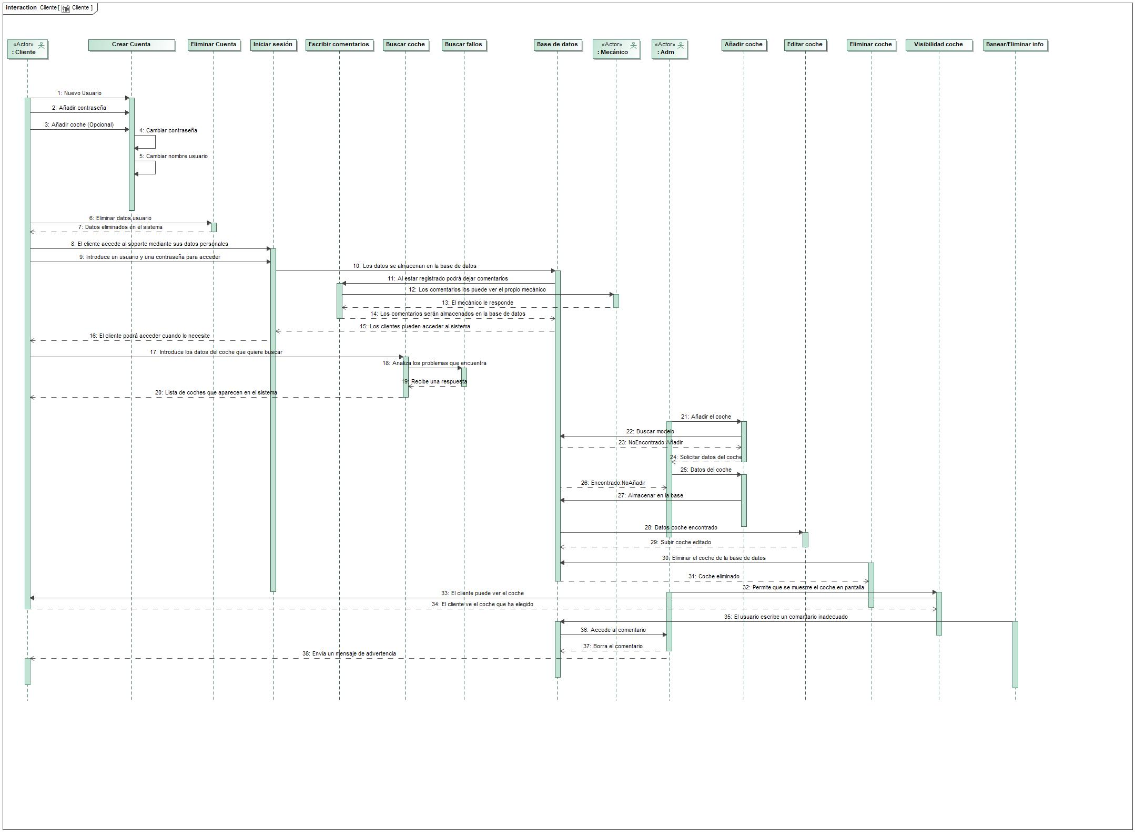

1. Cliente

## Model

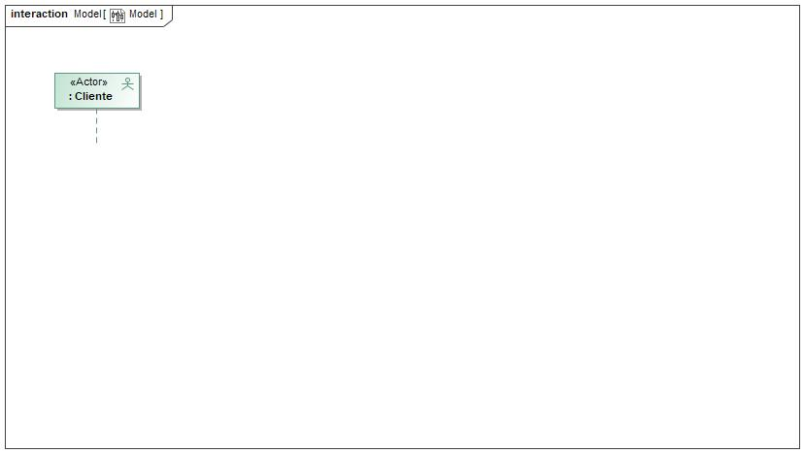

1. Model